Tai Tham MY Keyboard Map
The Tai Tham MY keyboard was developed for typing Tai Lue language in Tai Tham script. The keyboard is available for computers as well as mobile devices.

Keyboard for Computer
There are 3 parts to the keyboard map: “Normal” part; “Shift” part and “Right Alt” part. The Normal part is shown below. To type the character you want, press the appropriate key.
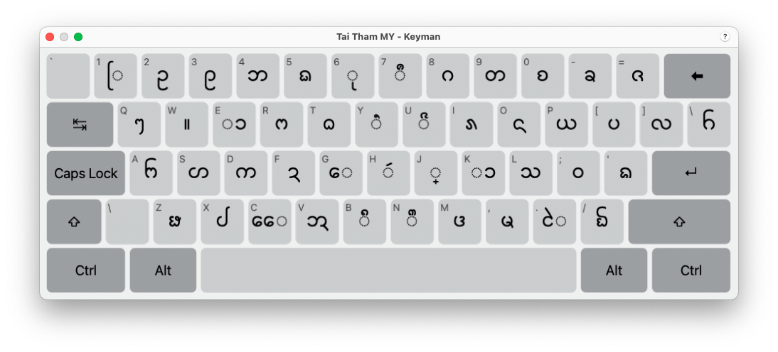
The Shift part is shown below. To type the character you want, press SHIFT + the appropriate key (at the same time).

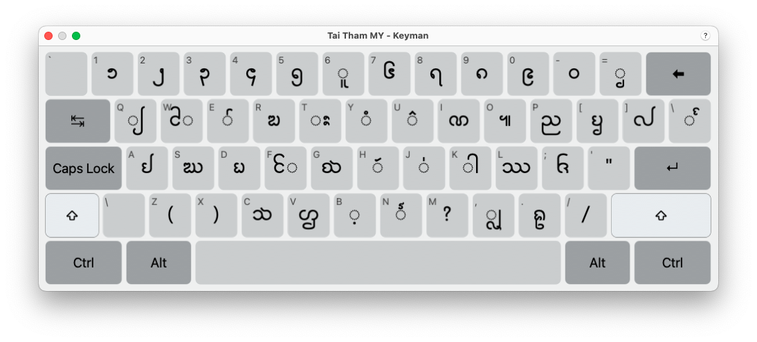

The Right Alt part is shown below. To type the character you want, press RIGHT ALT + the appropriate key (at the same time).

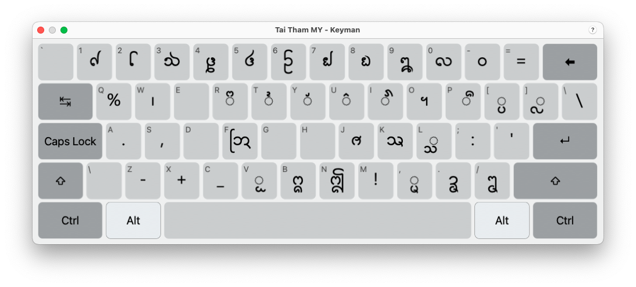
The ᩠ character (found in the Normal part) has a special function: it allows you to create a subjoined character. Having typed the ᩠ character, just type the character you want to be subjoined. For example, ᩅ + ᩠ + ᨶ + ᩢ gives ᩅ᩠ᨶᩢ

Keyboard for Mobile Devices
There are 3 parts to the keyboard map: “Normal” part; “Shift” part and “Right Alt” part. The Normal part is shown below. To type the character you want, press the appropriate key.

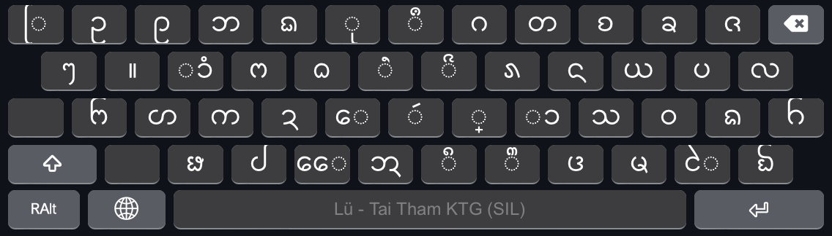
The Shift part is shown below. To type the character you want, press SHIFT + the appropriate key (at the same time).
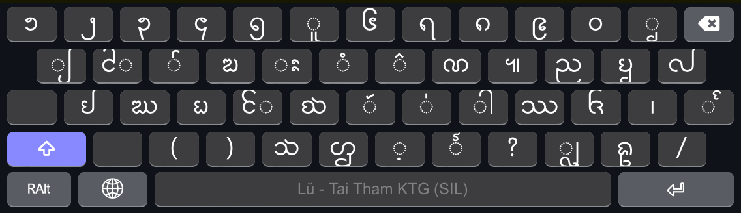
The Right Alt part is shown below. To type the character you want, press RIGHT ALT + the appropriate key (at the same time).

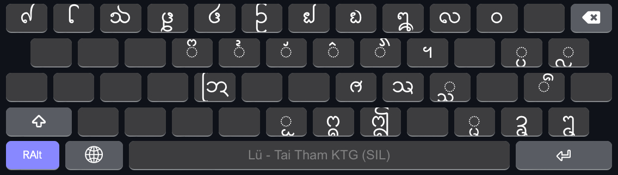
The ᩠ character (found in the Normal part) has a special function: it allows you to create a subjoined character. Having typed the ᩠ character, just type the character you want to be subjoined. For example, ᩅ + ᩠ + ᨶ + ᩢ gives ᩅ᩠ᨶᩢ

